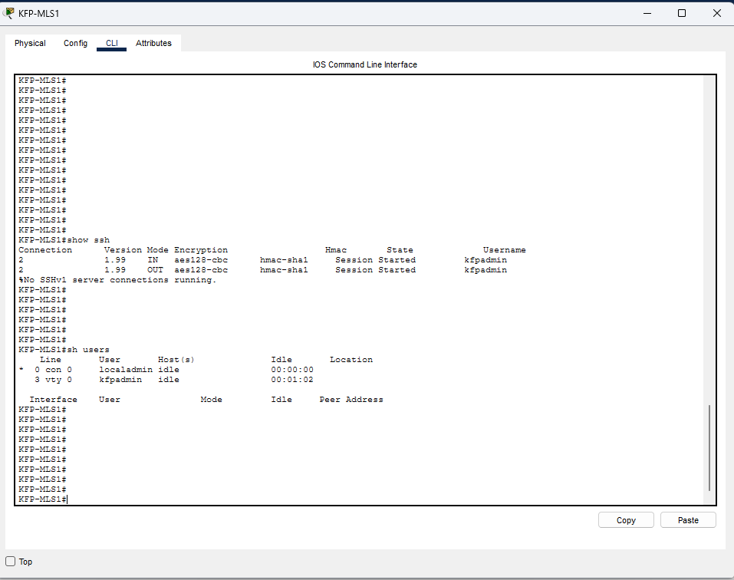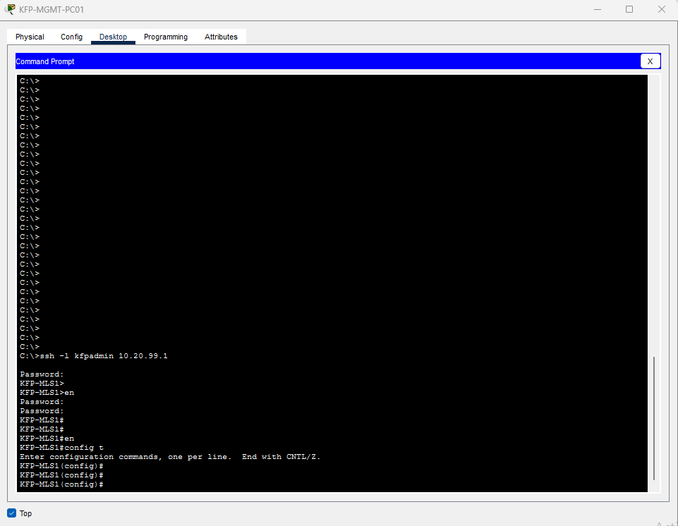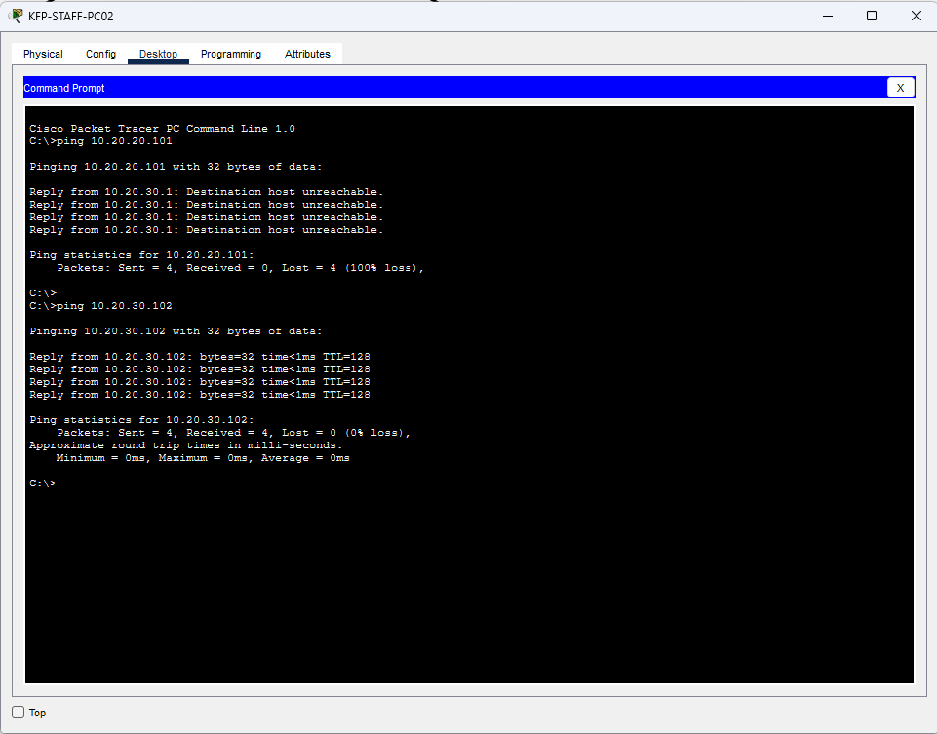

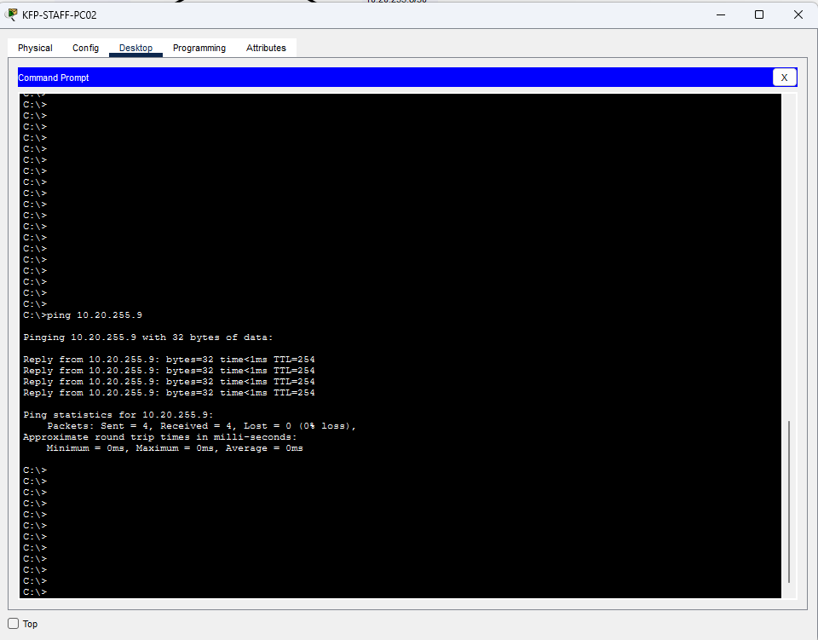

Extended ACL cross-test: PASS
Tester: Matthews Martinez | Implementer: Benjamin Popso | Date: 2026-11-08
ACL: GENERAL-STAFF-ACL on KFP-MLS2, Vlan30 inbound (confirmed in running-config); matches documentation: yes
Permitted flow: KFP-STAFF-PC02 (VLAN 30) to 10.20.40.10 (VLAN 40) and 10.20.255.9, ICMP: succeeded, 4/4 replies each; line 80 counter 0 -> 16
Prohibited flow: KFP-STAFF-PC02 (VLAN 30) to 10.20.20.101 (VLAN 20), ICMP: denied, 0/4 replies, gateway 10.20.30.1 returned Destination host unreachable; line 10 counter 0 -> 8 (two test runs)
Additional check: KFP-MGMT-PC01 SSH to KFP-MLS1 (10.20.99.1) as kfpadmin succeeded; confirmed with show ssh and show users (vty 0).
Exceptions/config changes: None. No configuration changes made. Note: show ip interface vlan 30 displayed "not set" (Packet Tracer display issue); running-config and counters confirm the ACL is applied.

